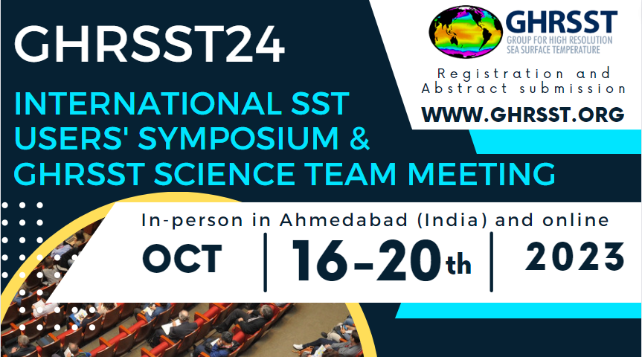

INSTRUCTIONS FOR ABSTRACT SUBMISSION
The International SST User Symposium and GHRSST International Science Team Meeting (GHRSST24) will take place from Monday 16 October to Friday 20 October 2023 as a virtual and in-person meeting in Ahmedabad (India), and it will be hosted by the Indian Space Research Organisation (ISRO).
Abstracts are invited within the following science sessions:
S1- Science applications for operational users of SST in India
S2- Processing and product generation
S3 - Calibration, Validation and Product Assessment
S4 - Retrieval Algorithms
S5 - Computing and products
S6 - High-Resolution Satellite Missions

Abstracts featuring GHRSST formatted products will be given priority.
Please note that abstracts should be no longer than 250 words.
To submit multiple abstracts, please send each one individually using this template.
Please send the abstract to GHRSST Project Office, Chiara Bearzotti (chb@dmi.dk), with ‘GHRSST 24 Abstract' in the subject.
Deadline for submission: 19th June 2023.

Looking forward to receiving your abstract!
The GHRSST Project Office

The GHRRST Project Office is funded by the European Union Copernicus Programme

Web: https://www.ghrsst.org
LinkedIn: https://www.linkedin.com/company/ghrsst
Twitter: https://twitter.com/GHRSST

Please do not change the formatting of the text below (font type, font size and colour)

Preferred type of contribution (talk or poster):_________
Preferred session (select from the list below):
S1- Science applications for operational users of SST in India
S2- Processing and product generation
S3 - Calibration, Validation and Product Assessment
S4 - Retrieval Algorithms
S5 - Computing and products
S6 - High-Resolution Satellite Missions

Title:
Submitting author/speaker (Name and Surname):
Institution name and address:
Email address:
Preferred participation (in-person or online):
Submission date: dd/mm/yyyy
Authors: Author (1), Author (2), Author (3)…
- Institution name and address, Author email address:
- Institution name and address, Author email address:
- Institution name and address, Author email address:

Abstract (no longer than 250 words)

